Travel Request System

# High-Level Technical Design

Version 1.0

12/10/2018

Document Number: TRS00WM01

Submitter By: Suresh Kanniyappan

Table of Contents

1. Introduction 3

2. Current System 4

2.1 Functional Description 4

2.2 User Community Description 4

2.3 Technical Architecture 5

3. Goals, Objectives, and Rationale for New or Significantly Modified System 6

3.1 Project Purpose 6

3.2 System Goals and Objectives 6

3.3 Proposed System 6

3.3.1 System Scope 6

3.3.2 High-Level Functional Requirements 6

3.3.3 Summary of Changes 6

4. Factors Influencing Technical Design 7

4.1 Relevant Standards 7

4.2 Assumptions and Dependencies 7

4.3 Constraints 7

5. Proposed *System* 8

5.1 High-Level Architecture 8

5.2 Application Architecture 9

5.3 Information Architecture 10

5.4 Data Flow Architecture 11

5.5 Technology Architecture 12

5.6 Security and Privacy Architecture 12

6. Analysis of the Proposed System 13

6.1 Impact Analysis 13

6.1.1 Operational Impacts 13

6.1.2 Organizational Impacts 13

6.2 Risks 13

6.3 Issues to Resolve 13

6.4 Critical Success Factors for Remainder of Project 13

## Introduction

Business Trading Company, also known as BTC was established in 1997 to fill the void which existed in Qatar for a retail environment offering the perfect mix of shopping, dining, and entertainment opportunities. BTC is famous both in Qatar and the entire GCC region for its proven expertise in the development and management of premium shopping malls, entertainment, real estate, and high end retail brands.

The purpose of this document is to define the scope of work, Development Approach, Out of Scope and Support Options for the development of Travel Request System.

## Current System

The Present System is a manual process where the employee rely on physical form which is filled with the required details and submitted to concerned team for further actions.

### Functional Description

The physical form is available to all the employees of an applicable Grade or above. The form is filled with the required details and given to the respective Manager for approval. Post which it will shared to the HR and the Travel department to book the tickets or approve the funds as applicable.

### User Community Description

Employees with a specific Grade or above

Employees with Manager Roles

HR personal

Travel Coordinator

Administrators

### Technical Architecture

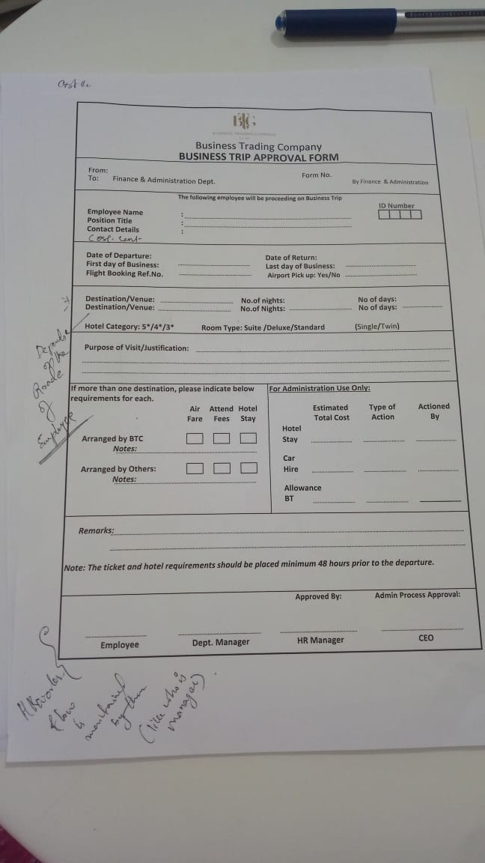

## Goals, Objectives, and Rationale for New or Significantly Modified System

In order to eliminate the manual process and also to the streamline the process for simple accessibility the new system will be developed as a web based application.

### Project Purpose

Create a web based system to automate the manual process of employee requesting for travel and the related process

### System Goals and Objectives

The new system will be able to avoid paperwork and help in saving time of employees along with having the option to track and review the request easily

### Proposed System

Web based application for intranet/internet purposes which will help the employees raise a travel request with ease

#### System Scope

The proposed new system will be an alternate for data capture, approval process and report generation of the travel request and will not have any sync services to other systems within or outside organization. In brief, it will function as an isolated website working with a database that may or may not be shared by other applications.

#### High-Level Functional Requirements

The proposed new web based system will be able to connect to the existing database to get the employee related data like personal details and employment details. The application will have a new login credentials set for the employees to access the application for raising/approving the travel request. It will also be able to manage and generate reports of travel related information like travel agencies, LPO and quotations.

#### Summary of Changes

Implementation of new system and not changing an existing system.

## Factors Influencing Technical Design

The below sections will describe the standards, assumptions, and constraints that influence the technical design of the proposed system.

### Relevant Standards

The new system will adhere to a standard authenticated and authorized website model along with using features/technologies that is compatible with all the major browsers in the market.

### Assumptions and Dependencies

The website will be designed under the following assumptions and dependencies

* The resources for the deployment of the website once developed will be present with BTC
* The deployment will be taken care by the developer but the daily maintenance of the website will not be taken up by the developer
* Access to the database schema(no data) will be made available to the developer before the development starts
* The system will not have any direct ties to other applications and thus no data sync will be required
* BTC will have a smtp or similar server available in order to use it to send/receive emails
* Reports generated will be of standard formats like pdf/word/excel, whichever is applicable
* All the actions in the system will be manual interactions and no automated activities will be present such as schedule notification, data transfer, etc.

### Constraints

Though the requirements are finalized, any of the below mentioned item might have significant impact on the design and delivery of the new system:

* Hardware or software environment during deployment
* End-user browser compatibility
* Any changes to the requirement mentioned in this document
* Delay in the getting required information for development/deployment

## Proposed *System*

Below section describes the operational requirements and technical design of the proposed system.

### High-Level Architecture

### Application Architecture

### Information Architecture

Database Schema and Table structure

### Data Flow Architecture

### Technology Architecture

Below are the details of the anticipated infrastructure that will be required to support the application and information architecture.

##### Platform

Target platform is any of the common browser like Chrome, Edge, Mozilla, etc.

##### System Hosting

Target platform is the Windows Server or any remote server that supports Microsoft applications like IIS and SQL Server

##### Connectivity Requirements

Network connectivity requirements for the system could be Internet if it has to be accessible outside office else Intranet if it has to be available only within the organization.

##### Modes of Operation

The modes that the system will operate in:

* The system will have three environments : development, test, and production
* There will be just one production instance of the system
* There will be no pilot and thus, no success criteria and exit strategy
* The new system will not convert the data from the current system

### Security and Privacy Architecture

There is no specific security and privacy architecture for the new proposed system other the basic authentication and authorization of the valid users of the application

##### Authentication

The basic user authentication approach to verify user identity before allowing access to the system i.e. Username and Password (encrypted)

##### Authorization

The approach for authorizing users to perform functional activity once logged into the system will be based on the roles and organizational information available on the current database

## Analysis of the Proposed System

Analyzes of the proposed system for its impact on the organization, analyzing risks, and describing remaining open issues (if any).

### Impact Analysis

The existing operations/ applications will not be affected by the new system as it will perform as an isolated stand-alone system.

#### Operational Impacts

NA

#### Organizational Impacts

NA

### Risks

The risks that the preferred alternative presents to the existing application is none as it is a stand-alone application and risks that will remain after implementing the design depends on how it will be used to integrate with other systems either internally or externally.

### Issues to Resolve

NA

### Critical Success Factors for Remainder of Project

NA